Creating the Methods (Edit)
Completing the Collection Class

Completing the Collection Class 1
Creating the Update Method 1

Completing the Collection Class

Creating the Update Method
Lastly we shall create the Update method.
Before we do anything start your Git Hub day.
Here is the full test…
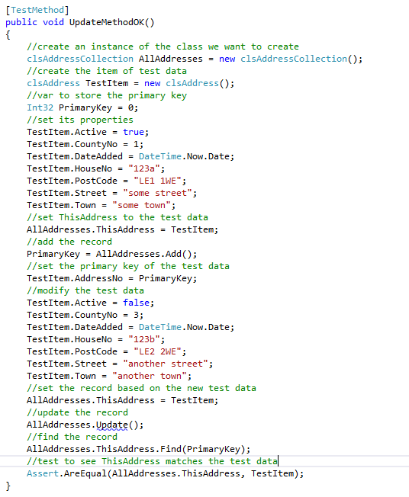
As usual it will fail due to lack of a stub for the method and a lack of code.
Here is the stored procedure we are using…
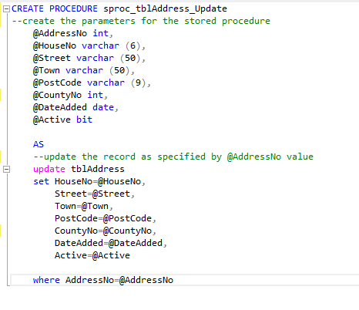
Worth pointing out that we do not write to the primary key in the “set” operation. Remember the primary key is read-only.
Here is the finished Update method…
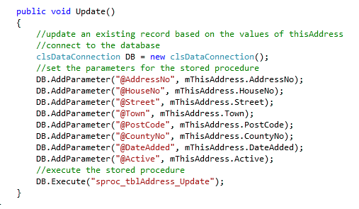
As before with Add and Delete we are now able to bolt the middle layer to the presentation layer.
In the form AddressList.aspx…
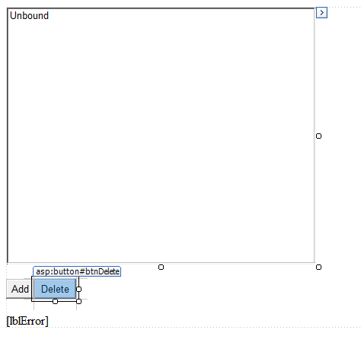
Add a new button for Edit called btnEdit like so…
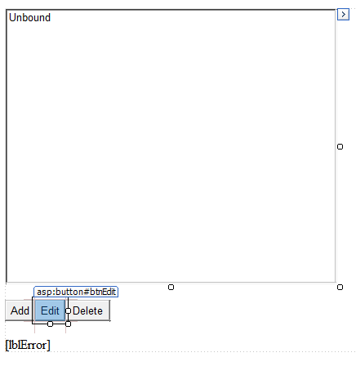
Access the click event handler for Edit…
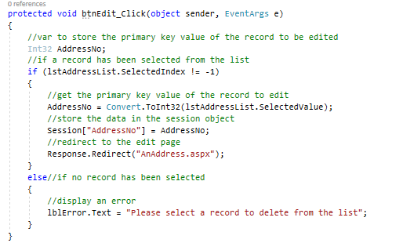
Note as with the Delete event handler we first check to see if the list has been selected and pick up the primary key value via the SelectedValue property of the list box.
Assuming it has we then place the primary key value into the session object.
Then we redirect to the page AnAddress.aspx.
Compare the event handler operations for Add and Update.
For Add we place a -1 in the session object like so…
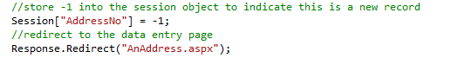
For Update we place the value of the primary key into the session object…
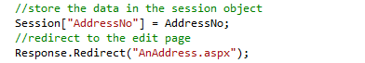
When we arrive in the page AnAddress.aspx we may use this to identify if the web form needs to add a new record or update an existing record.
The following code in the load event of AnAddress.aspx obtains this primary key value…
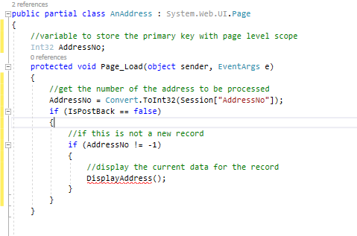
Notice how the AddressNo variable is declared with page level scope.
If we are to edit existing data to the user we need to display that data on the web form. The function DisplayAddress does this…
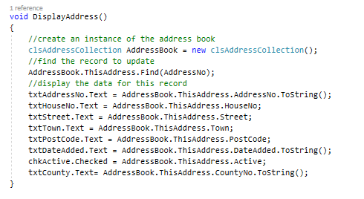
Finally, we need to update if statement in the event handler for the OK Button…
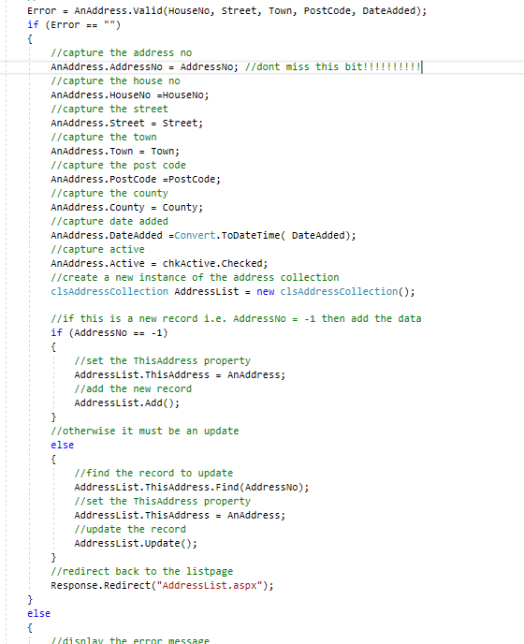
The last thing to do is to end your Git Hub day.

